# Description of Key Initialization

Take vial interface as an example:

0 layer(win layer)

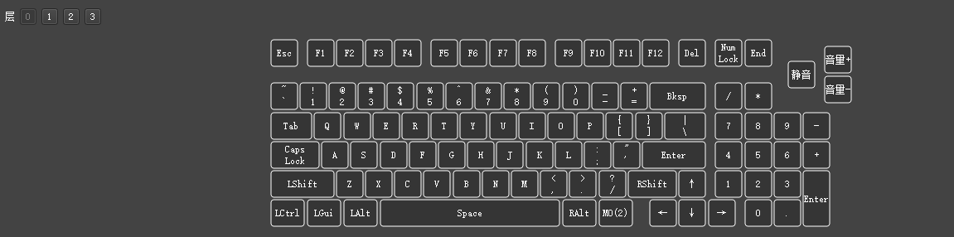

1 layer(mac layer)

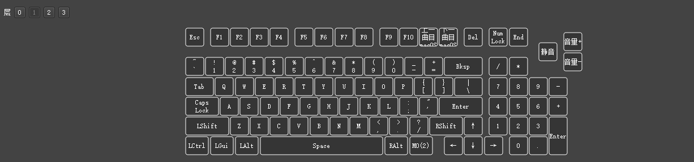

2 layer(light layer)

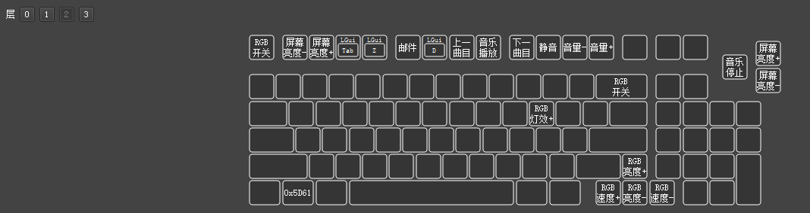

Change the layer by flipping the switch next to the USB port.

Hold MO(2) to enter the light layer, and exit the light layer after releasing.

The three indicator LEDs show whether the Caps lock, Num lock, or mac layer are enabled or disabled.

The Mac indicator LED will only stay on when keyboard is at the Mac layer.

**Specific key description: 0x5d61**

The key, commonly known as the Windows lock key, is used to enable or disable the win key function. Due to the reason of adaptation, this key can only be displayed as its key code.